Assignment

CMPE 280

GoogleCharts(BuildYourOwnPizza)

**Learning Objectives:**

Google Charts

**Build Your Pizza Pages:**

1. **Size & Crust**

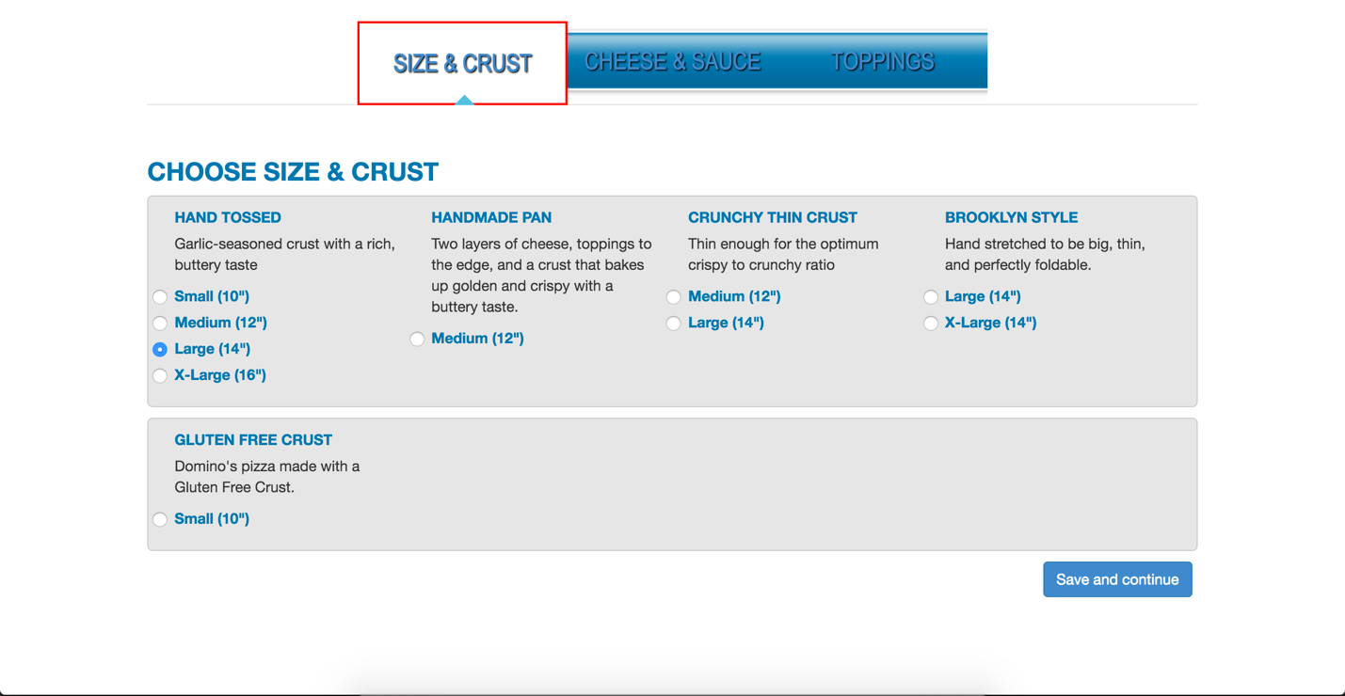

1. **Cheese & Sauce**

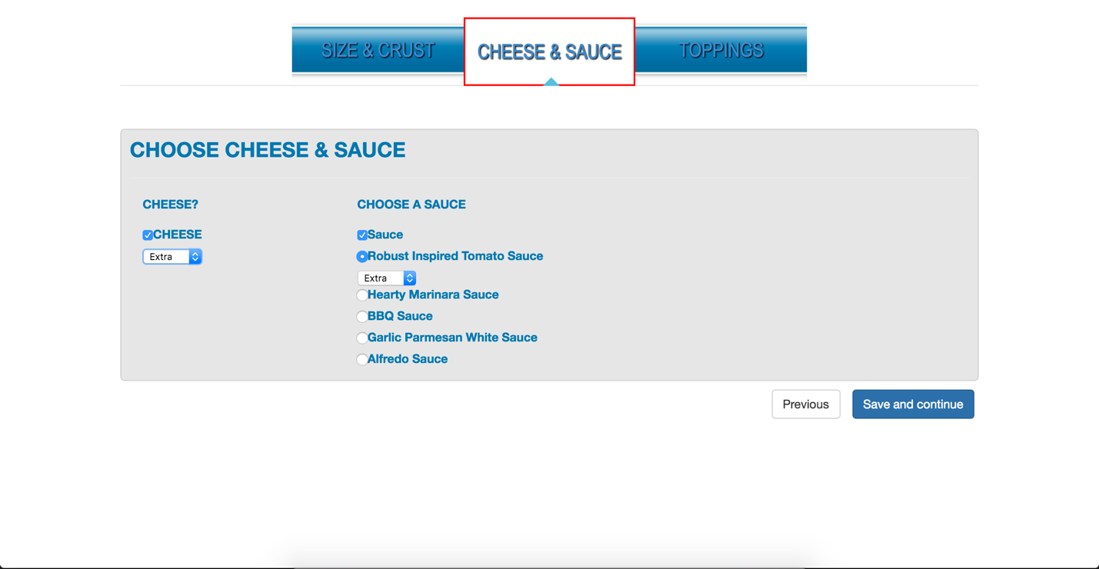

1. **Toppings**

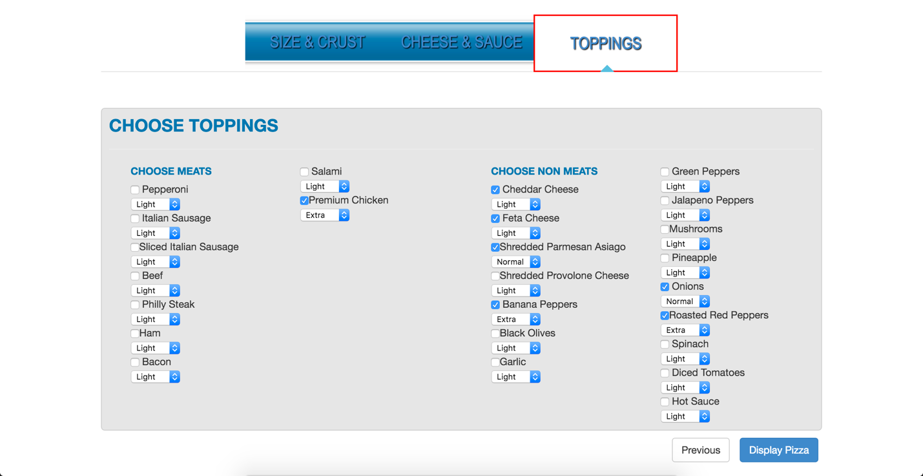

**Pizza Charts**

1. **Sankey Diagram**

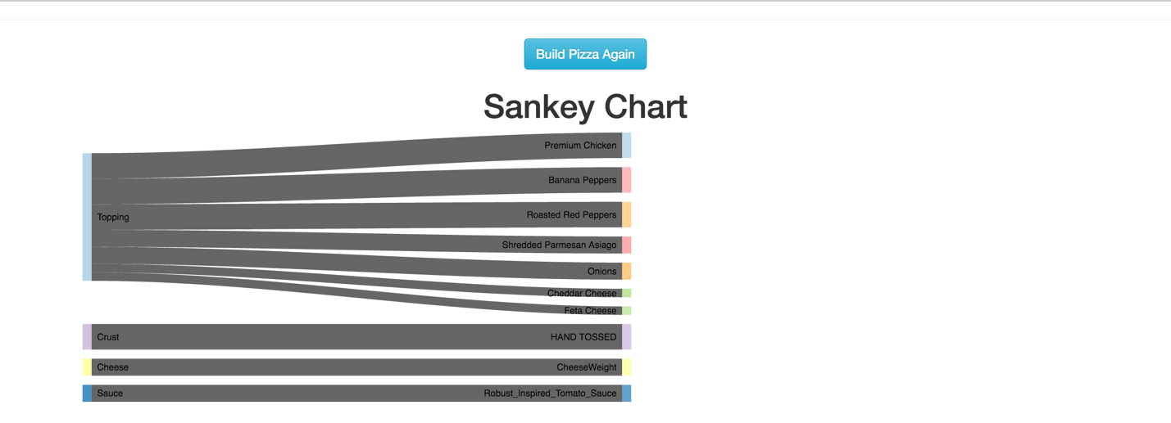

1. **Pie Chart**

